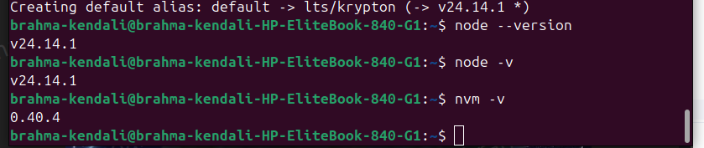
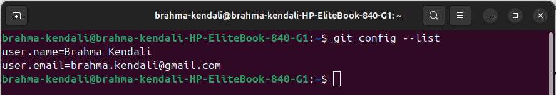
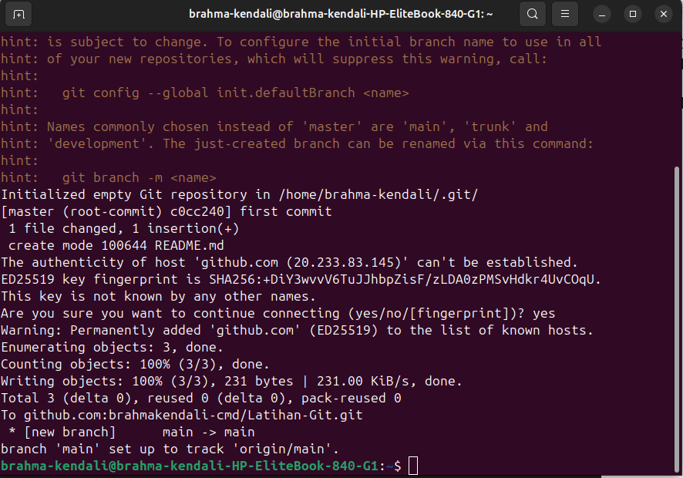
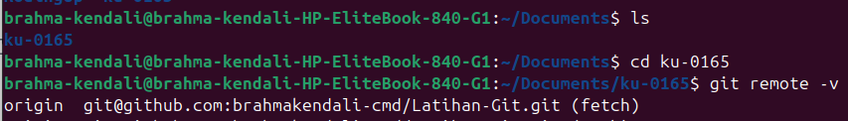

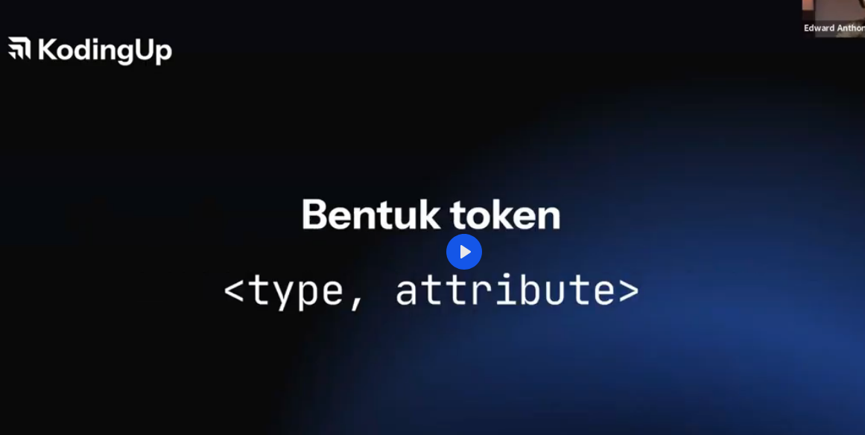
https://masb0ymas.com/blog/bagaimana-cara-setup-git-dan-github-pada-local-device

Generating public/private ed25519 key pair.
Enter file in which to save the key (/home/brahma-kendali/.ssh/id_ed25519):
Enter passphrase (empty for no passphrase):
Enter same passphrase again:
Your identification has been saved in /home/brahma-kendali/.ssh/id_ed25519
Your public key has been saved in /home/brahma-kendali/.ssh/id_ed25519.pub
The key fingerprint is:
SHA256:wKOmCjcOW29YpO0YBlbdHdHmjMJXL+uJMfV2pRhrTSE brahma.kendali@gmail.com
The key's randomart image is:
+--[ED25519 256]--+
| . . .o+ |
| . o . . +E . |
| . = * .. . |
|.. .. = o =... .|
|.. +o S . +* ..|
| +oo o .+oo. |
|o.=* =.o . |
|.Booo . o |
|o ... |
+----[SHA256]-----+
